

Student Name : Albeena AL momani

Trainer Name : Mohammad Bassam

GAME : SPACE SHOOTER

From Sunday (13/1) TO Monday (14/1)

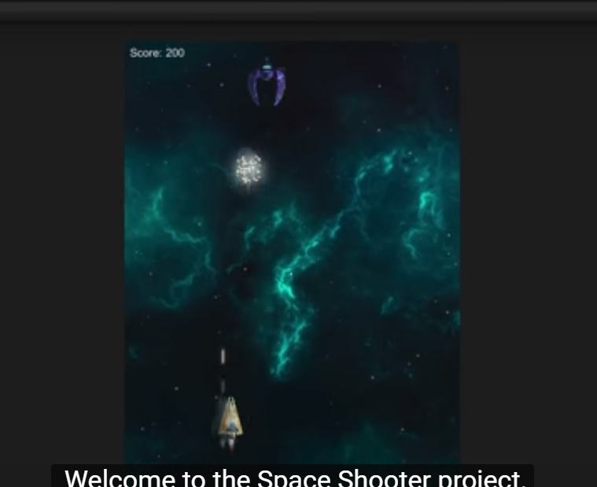

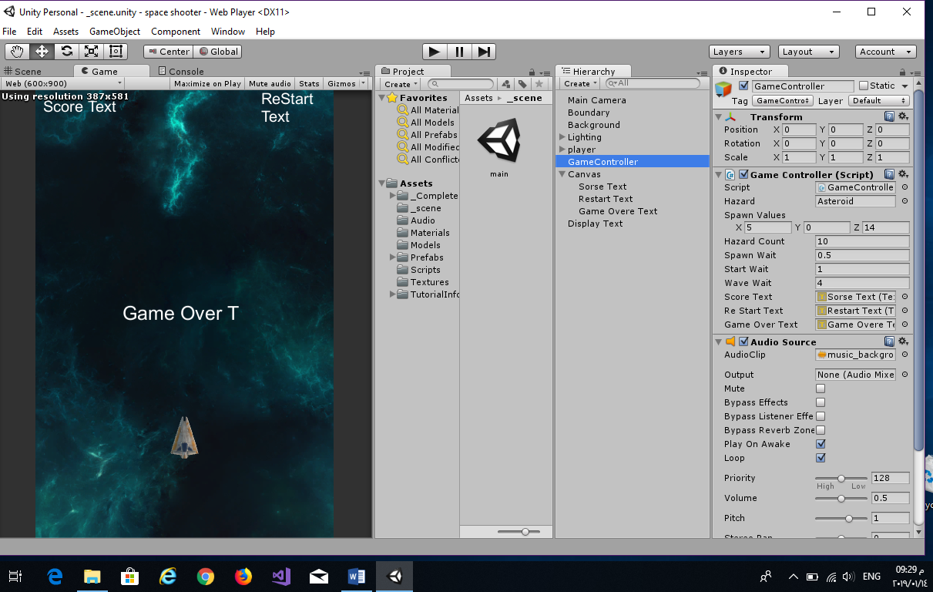

I have learned how I can add explosions to the scene when hazards or the player is destroyed .

And I have learned new things about c# language like (WaitForSeconds, IEnumerator, Quaternion , …)

how I can control of the Game in term of hazard , scour, texts, audio effect for background , explosions and the weapons .

Build the project as a web player and deploy the game to the web .